Lab Tasks

Task 01: The number stored in the variable testInteger is out of range.

Task 02:

#include<stdio.h>

main()

{

int Num1;

int Num2;

int Num3;

printf("Enter 3 different numbers: ");

scanf("%d%d%d", &Num1, &Num2, &Num3);

if (Num1>Num2 and Num1>Num3)

printf("The first number entered is the greatest...");

else if (Num2>Num1 and Num2>Num3)

printf("The second number entered is the greatest...");

else

printf("The third number entered is the greatest...");

}

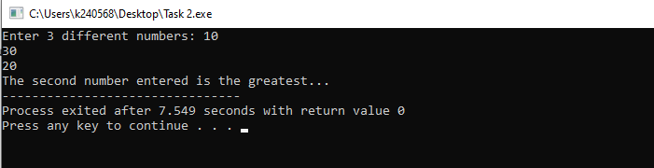

Task 03:

#include<stdio.h>

main()

{

float amount;

float foreign_currency;

printf("First enter the amount of local currency then enter the conversion rate for the foreign currency: ");

scanf("%f%f", &amount, &foreign_currency);

float final_amount;

final_amount = amount * foreign_currency;

printf("The equivalent amount in the foreign currency is: %f",final_amount);

}

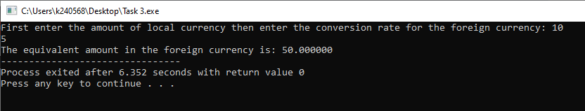

Task 04:

#include<stdio.h>

main()

{

int number;

printf("Enter a number: ");

scanf("%d", &number);

if ((number % 2) == 0)

printf("The number is even...");

else

printf("The number is odd...");

}

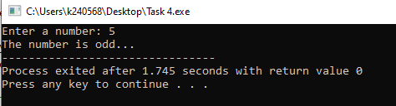

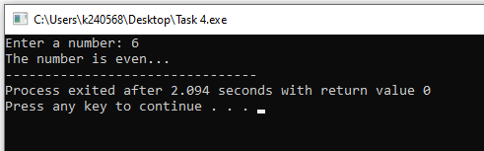

Task 05:

#include<stdio.h>

main()

{

float original_price;

float discount_rate;

float final_price;

printf("Enter the original price and the discount rate: ");

scanf("%f%f", &original_price, &discount_rate);

if (original_price > 100 and original_price < 50000 and discount_rate > 5 and discount_rate < 30)

{

final_price = original_price*(1-discount_rate/100);

printf("The final price is: %f" , final_price);

} else {

printf("Error in original price and/or discount..."); }

}

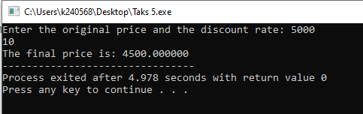

Task 06:

#include<stdio.h>

main()

{

float radius;

float height;

const double pi = 3.14159;

float volume;

printf("Enter radius then height of the cylinder: ");

scanf("%f%f", &radius, &height);

volume = radius * radius * height * pi;

printf("The volume is: %.3f", volume);

}

